Roll no. SP24-BSE-080

Submitted by: MUHAMMAD REYAN

Submitted to: M. SHAHID BHATTI

OOP LAB ASSIGNMENT 2

PERSON DETAIL ADDING FORM

**Information Form**

**For Adding person’s Details:**

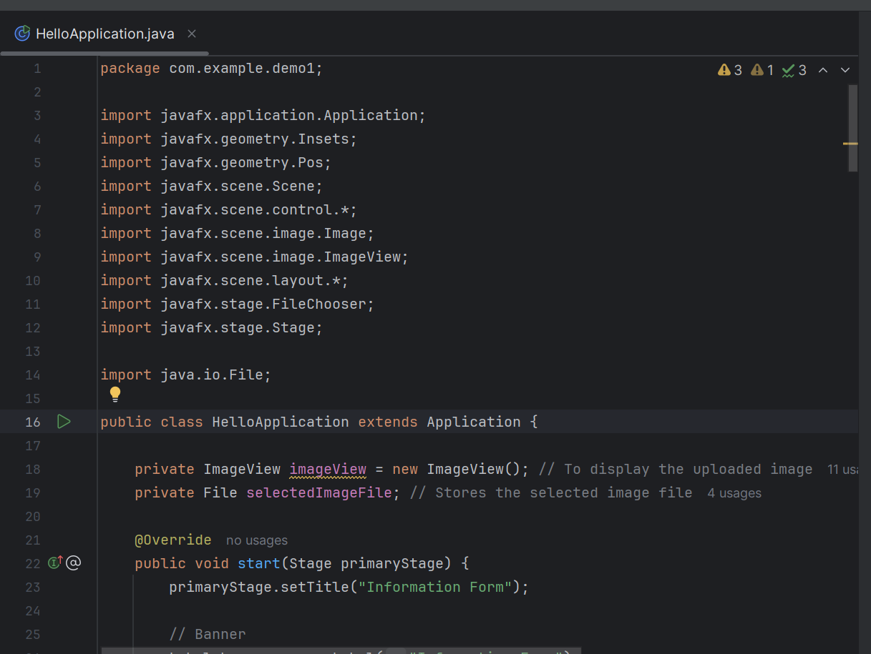

* This is the start of my code where I import different JavaFX libraries,

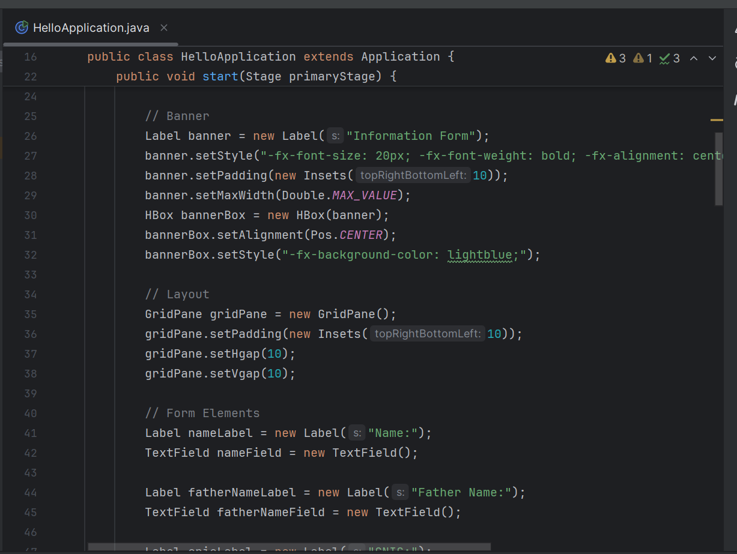

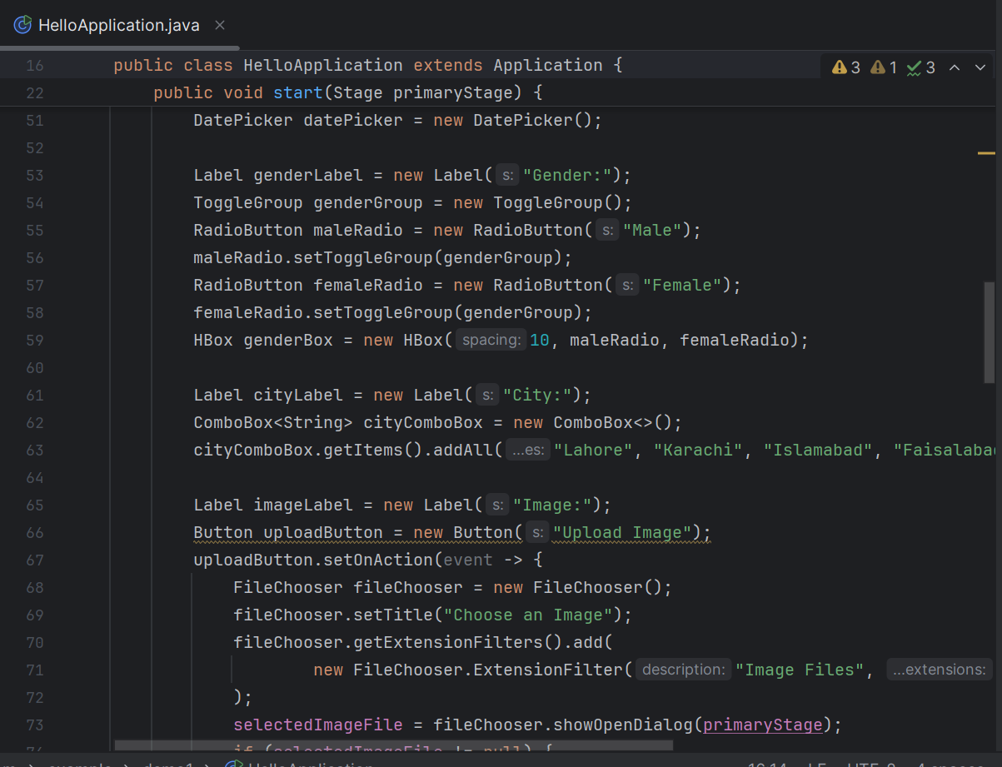

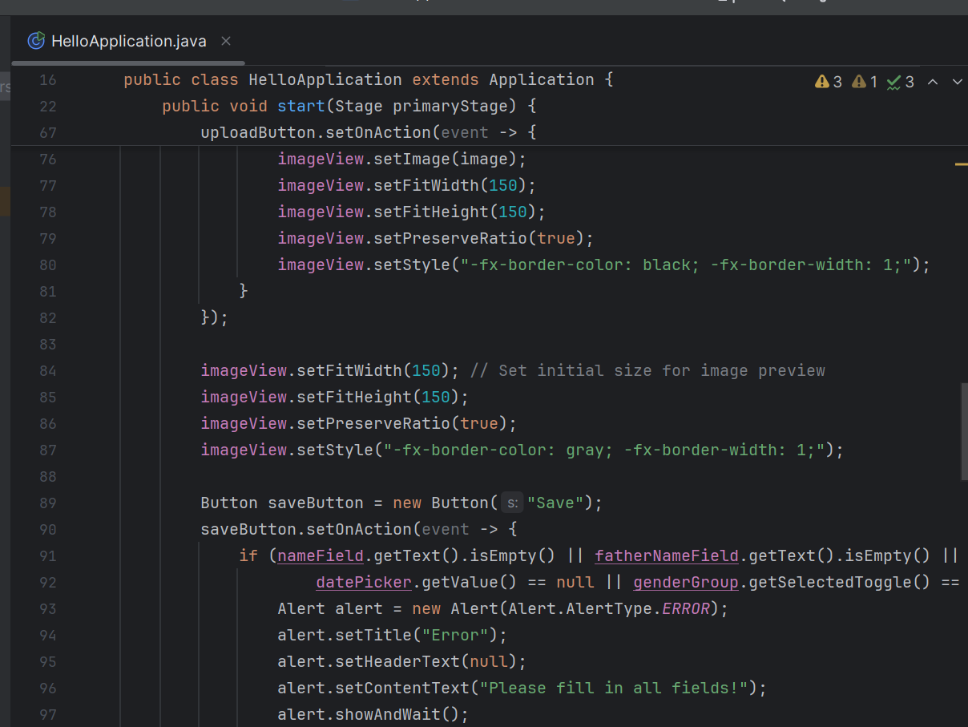

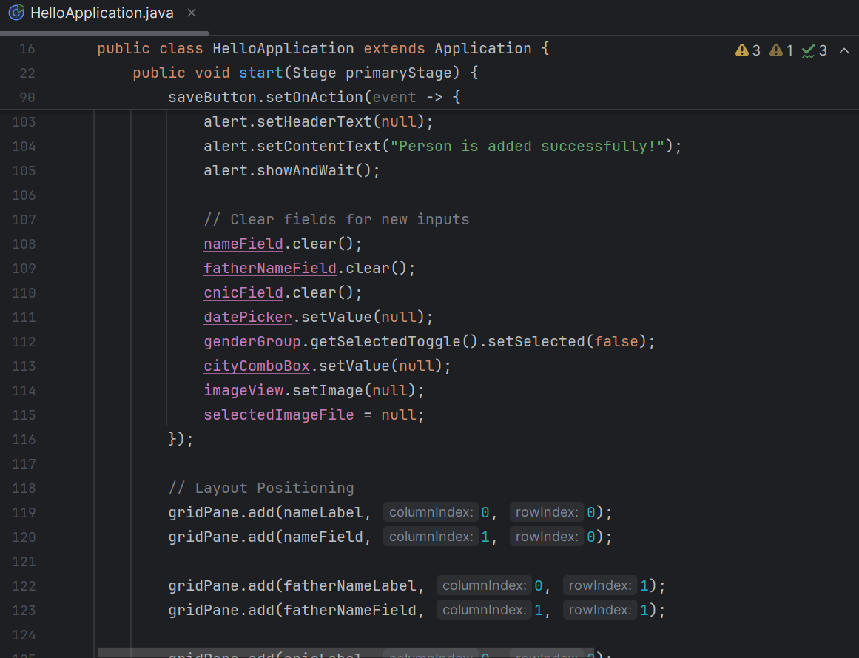

* This is the code I write for the formation of form which will be used to add person information.
* The following will be the output of that code.

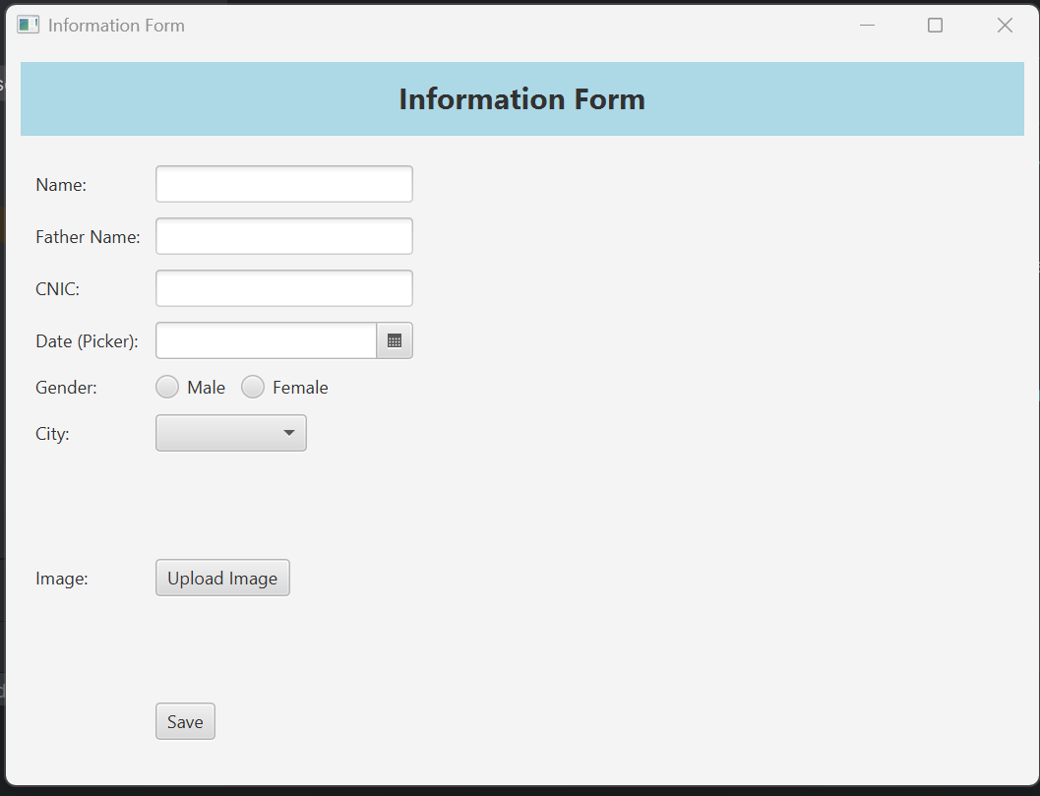

* This is the form front layout.
* And when I put input in it and save it.
* It will give me the message of the person added successfully.
* And will show the new screen.

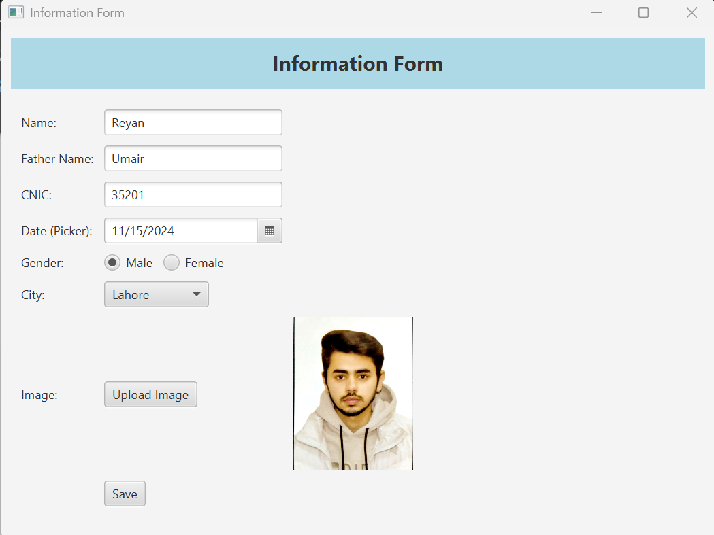

* I have put all the details in it and when we upload images from our laptop the image will be displayed here like that and when we press save button the info will be saved.

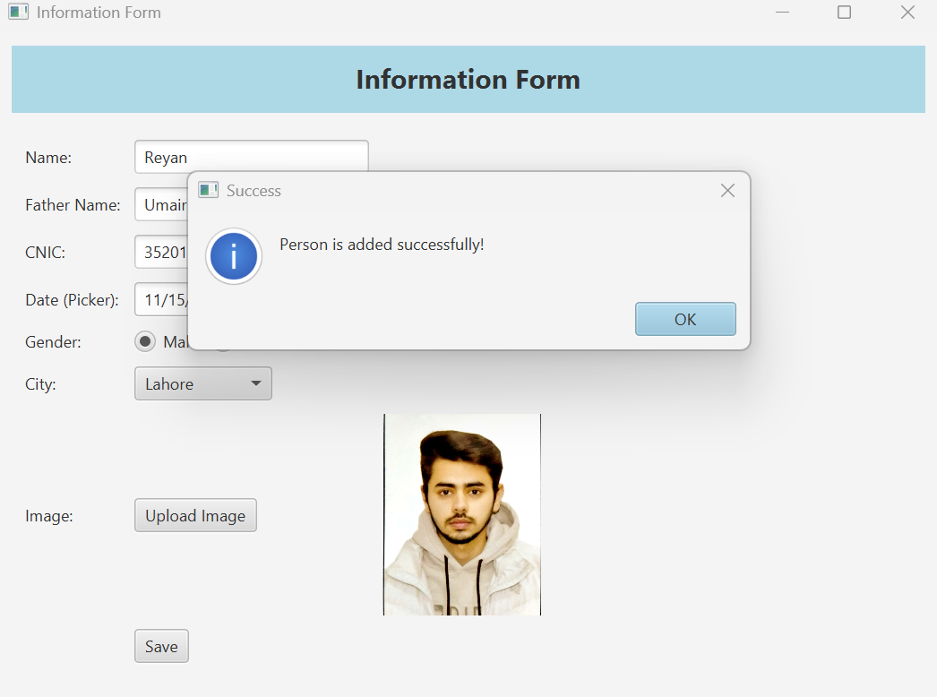

* Message is displayed person is added successfully.
* By pressing ok, the new screen will be displayed again for new person details.

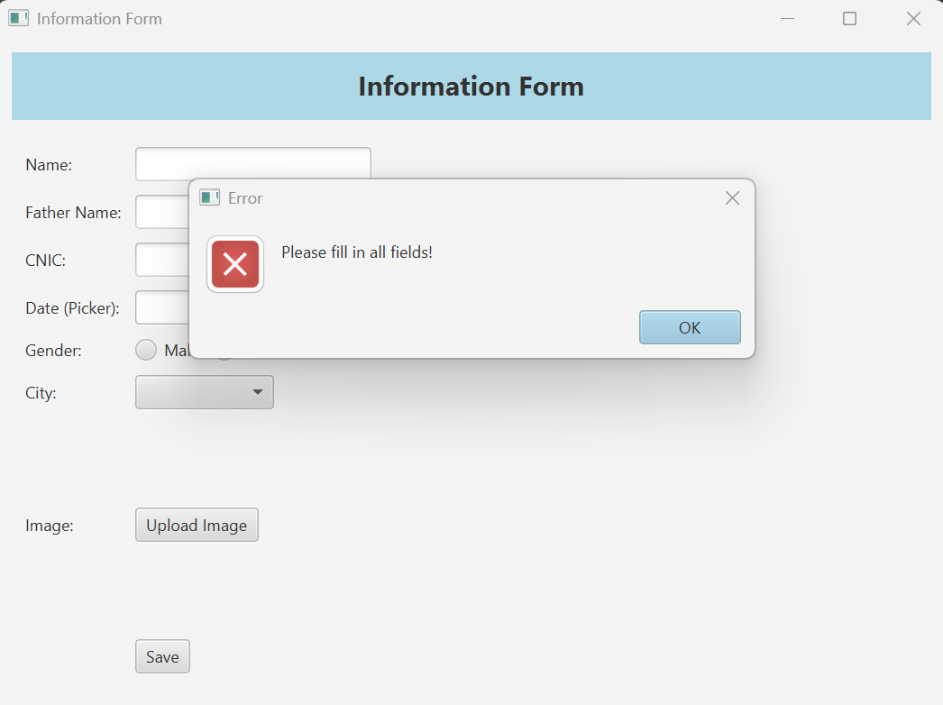

* If I don’t add any details and press the save button this message will be displayed.

**That’s All**

**Thank you so much!**